# CS 255 System Design Document

## UML Diagrams

### UML Use Case Diagram

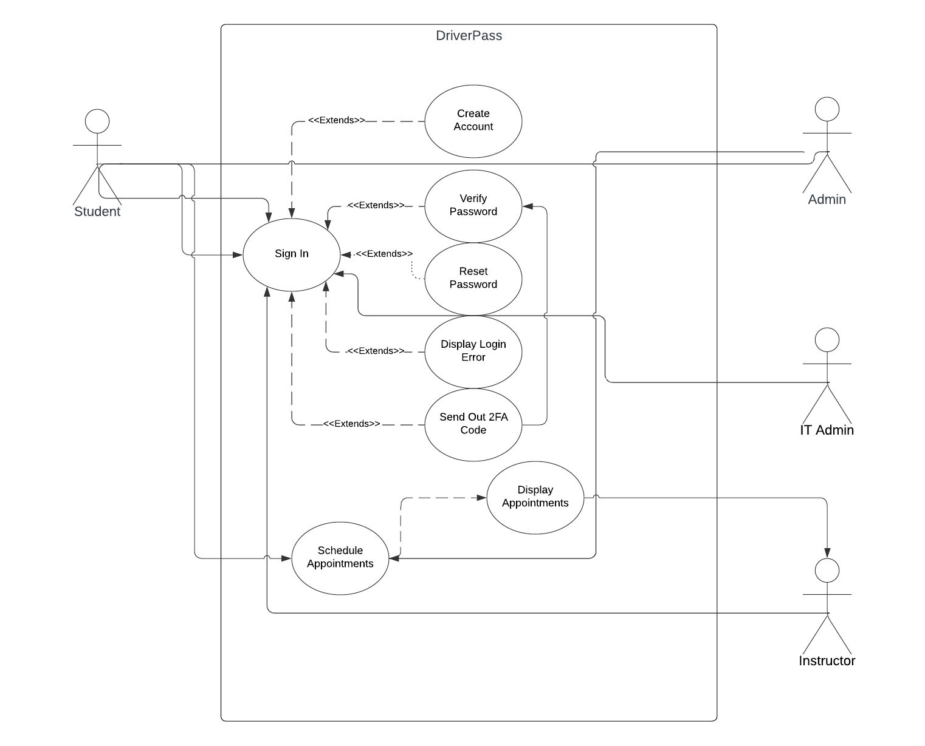

### UML Activity Diagrams

### UML Sequence Diagram

*[You were asked to create a sequence diagram based on* ***one*** *of the use cases you chose. Please insert your sequence diagram here. Check to make sure that you included appropriate components and symbols and that your design meets the client’s needs.]*

### UML Class Diagram

*[You were asked to create a class diagram based on the different classes and attributes needed for your system design. You are* ***not*** *required to include methods, but you may if you wish. Please insert your class diagram here. Check to make sure that you included appropriate components and symbols and that your design meets the client’s requirements.]*

## Technical Requirements

* **Software**
  + Backup software for our data and website
  + Malware prevention software
  + Windows Server to host the server.
  + SQL Server to run the website with Apache
* **Hardware**
  + Internet Modem
  + Server Rack to hold the storage and processing
  + Storage drives for all the data
  + A dedicated router or physical firewall for security